*EXPECTATIONS:*

* *Students will treat their peers, the instructor, the classroom, and the equipment with respect.*
* *Each student is expected to follow the school's code of conduct (No cell phone or ear phone usage).*
* *Students will arrive in class and be seated before the bell rings. Three tardies equals detention.*
* *Students will come to class prepared and keep an organized notebook.*
* *No Food or Drink in the Science Lab*
* *Use the restroom before class. Students are not allowed to leave class during lecture or lab activities.*

*Assessments 70%*

* *Projects*
* *Daily Quizzes*
* *Labs/Lab quiz*

*Assessments may be retaken by objective sections for replacement grade up to the final week of the quarter.*

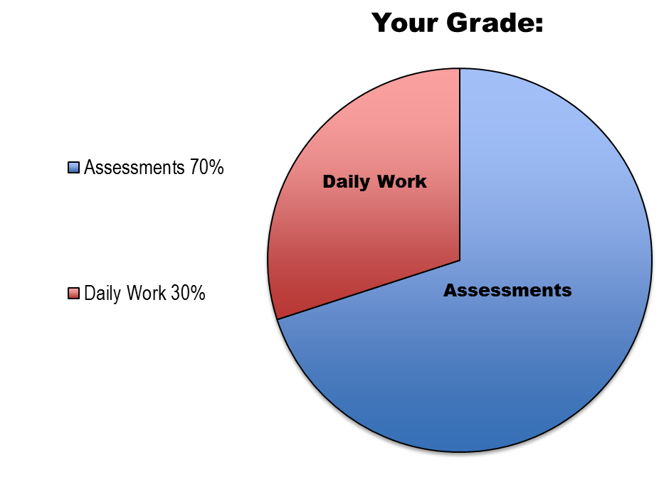

*Daily work 30%*

* *Daily Bell Ringers*
* *Projects*
* *Notebooks*

*Daily work will only be accepted for 2 weeks pat the assigned due date. All work turned in after the assigned due date will receive a deduction in points.*

*REQUIRED MATERIALS:*

* *3-ring binder*
* *loose leaf paper*
* *writing utensils*
* ***colored pencils***
* *School issued Google id and password*
* *Engineering Notebook*

*.*



*EXPECTATIONS Continued:*

* *This is a lab based course. If you fall behind or miss a day it is essential you make up work as soon as possible.*
* *Questions regarding assignments: DO NOT walk into class with undone homework expecting an answer.*

It is my job, as teacher, to maintain an environment in which all students can learn comfortably. Therefore, disruptive, inappropriate, and disrespectful behaviors will not be tolerated. Expected behaviors may need to be reinforced until a solution can be reached, including consequences.

*.ES Unit Summary*

*Unit1..................Introduction to Environmental Sustainability*

*Unit2..................Ensuring Safe and Abundant Water*

*Unit3..................World Food Security*

*Unit4..................Renewable Fuels*

FIND ME HERE:

All websites are not personal and are strictly for professional use.

http://meisnerscience.weebly.com/

EXTRA HELP:

Before school from 7:20 to 1st hour

After school until 3:50

EMAIL:

smeisner@sbps.net

