Afterlife
The Strange Science of Decay

- Explain the idea that “life relies on death.”

- List the three agents of decay.

Day 2 / Preserving Food
- What is causing the initial discoloration of the chicken?

- Why do the pseudomonas get a head start on the chicken?

- Explain how the blow flies respond to the decay action of the bacteria.

- MREs have a shelf life of three years. How are they preserved?

- Sugar is added to jam to preserve it. How does it work?

- Packets of iron filings were placed in the sandwich packs. How do these slow down decay?

Day 8 / Carboniferous Period
- What two insect decomposers are present by this time?

- Label the fruiting body, filament, and spore heads in the mold diagram below.
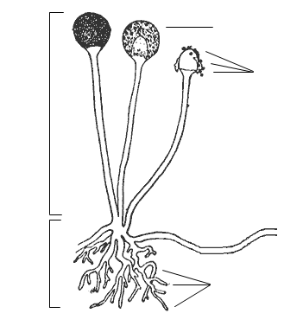

- In general, what food sources do molds prefer?

- Mold and bacteria compete over the same food sources. How do molds fight off the bacteria?

- Explain how ingesting mold can be dangerous to humans.

- What happened when trees first evolved wood during the Carboniferous Period that couldn’t be decayed.

  - Effect on atmosphere:

  - Effect on insects:

- The fungus decomposing lignin in the wood piece was growing hyphae. Explain what these are for.

Day 16
- Why did the Sexton Beetles bury the rat?

- Which types of foods do maggots prefer?

- Why do maggots feed as a pack instead of separately?

- Label the hooks, circular bands, and spiracles of the maggot.
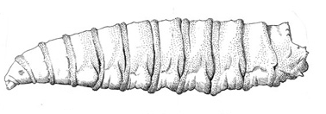

- Explain the function of each of the parts of the maggot.
  - Hooks –
  - Circular Bands –
  - Spiracles –

- Why do maggots breathe out of their rear instead of their front?

- Humans find the smell of decaying material to be offensive and repellant. Why might we have evolved this revulsion?

Day 23 / Decay Forensics
- Fish and meat produce a much more repulsive smell when rotting than fruit or vegetables. Why is this?

- Explain the physical differences between the two pigs shown in the experiment:
  - Pig 1 (Bloating) –

  - Pig 2 (Liquifying) –

- How is the “fingerprint of decay” measured?

- What applications might measuring soil like this have for forensic science?

Day 37 / Slime Molds
- What effect do the flies have on the molds growing on the fruit?

- Why do some fungi, like the stinkhorn, attract flies?

- Why do slime molds grow multiple tubes that connect to each of the oat flakes (food)?

- How do slime molds transmit information across their entire network?

Day 44
- What is different about the conditions of the house that favors larder beetles instead of flies?

- Describe what the sexton beetles did with the rat carcass.

Day 52
- Explain how nitrogen atoms are transferred from dead mustard plant material into new marigold seedlings.

