Global Climate Change
Notes outline to accompany the Global Climate Change Powerpoint
http://www.docstoc.com/docs/69621520/Environmental-Science-Lecture-Powerpoint-Global-Warming--Climate-Change

- Define weather -

- Define climate -

  - The four main factors that determine climate are:

- What is the atmosphere?

  - How thick is the atmosphere compared to the Earth?

- The troposphere is the _______________ and ____________ part of the atmosphere.

- Looking at the picture, list the four layers of the atmosphere starting with the one closest to Earth:

- The troposphere is the _____________ and _____________ part of the atmosphere.

- What occurs in the troposphere?

- How does this layer relate to global warming?

- Describe the stratosphere -

  - What does this layer contain?

- Of all the solar radiation reaching the Earth,…

  - 25% is _________________

  - 25% is _________________

  - 50% _ _________________

- Of the solar energy that reaches the surface…

  - Fresh clean snow reflects _____________

  - Dark soil reflects ________________

  - The average reflection is _____________.

Greenhouse Effect

- Infrared energy that reflects off the Earth’s surface is trapped by ____________________
_______________________________________________________________________.

  - Why is this process normal and necessary?

  - How is this currently changing?

- Give the source of each of these greenhouse gases:

  - Carbon dioxide:

  - Methane:

  - Water Vapor:

  - CFCs:

  - Nitrous Oxide:

- Which of these two greenhouse gases are the biggest contributors to global warming?

- The amount of _____________in the atmosphere directly affects _________________

______________________________.

- Warm air containing water _______________________________________. This occurs

because warm air is ________________ than cool air. As the warm air rises, heat is

______________ into the atmosphere and the water vapor ___________________.

  - What happens to the condensed water?

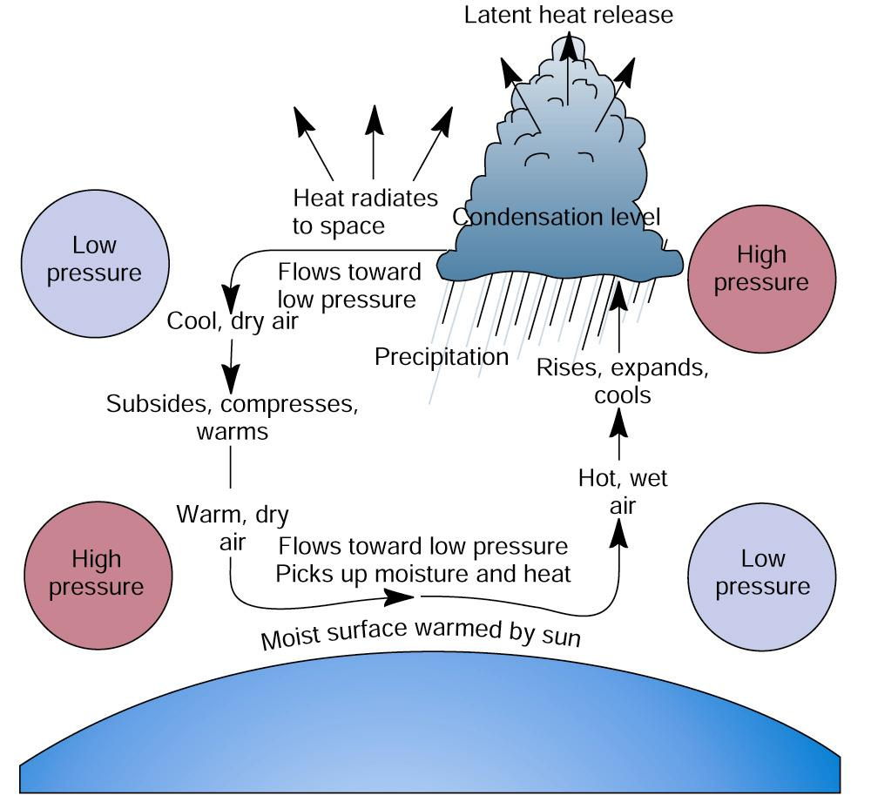

- Give three different ways that the Earth’s climate has changed throughout history:

Evidence of Global Warming

- How much has the Earth surface temperature increased since 1880?

  - How fast is the Earth warming?

  - When have the warmest years on record occurred?

  - How does this affect the Arctic?

- What are the three observations mentioned by the IPCC 2007 report?

- According to the IPCC 2007 report, what is the most likely cause of these observations?

Global Warming Timeline

19th Century:

1958:

1970:

1973:

1977:

1981:

1995:

1997:

1998:

2003:

Day After Tomorrow (2004)

- What specific visuals does this movie give in regards to global climate change?

Tokyo, Japan:

Los Angeles, USA

New York City, USA

- What three events occurred in 2005 relating to global climate change?

- What documentary is released in 2006?

Measuring Carbon Dioxide in the Atmosphere

- Where is the carbon dioxide detector located?

  - This location allows for measurements: _________________________________

_________________________________________________________________.

  - Where does the air entering this area come from?

- What was the concentration of CO2 in 1960?

- What was the concentration of CO2 in 2000?

- What exactly is the relationship between carbon dioxide and global temperature?

  - Are there any areas of the graph where they do not match up?

- All temperature data before 1880 is the result of “proxies.”
  - What is a proxy?

  - Give two examples of proxies:

- The data from Antarctic ice cores only goes back ______________ years.

  - Why is this limited?

- What is another source of data that goes back even farther?

  - How can isotopes of water be used to determine global temperature?

- What changed at the end of the end of the last ice age?

- Describe the temperature pattern over the last 1,000 years.

Medieval Warming Period and Little Ice Age

- When did the Medieval Warming Period Occur?

- What two major effects did this have on the Western Europeean civilizations?

- How did this affect the other continents?

  - How does this relate to the Mayan empire?

- When did the Little Ice Age occur?

- What two major effects did this have on the Western European civilizations?

- What are the three likely causes of this little ice age?

- Describe the temperature pattern over the last 130 years.

Hurricane Katrina

- When did Hurricane Katrina form?

- Why did the hurricane become so strong so quickly?

- What were the two main reasons why New Orleans was so badly damaged?

Global Warming and Hurricanes

- Is there any evidence to link climate change to frequency of hurricanes?

- How specifically are hurricanes affected by global warming?

El Nino and La Nina

- Define El Nino -

  - Where is this located?

  - Where is it found most of the time?

  - How often does it move, and where does it go?

- What is the weather like during an El Nino year?

- What is the weather like during a La Nina year?

Great Ocean Conveyoru

- Draw in the warm and cold currents of the great ocean conveyor in the map below:

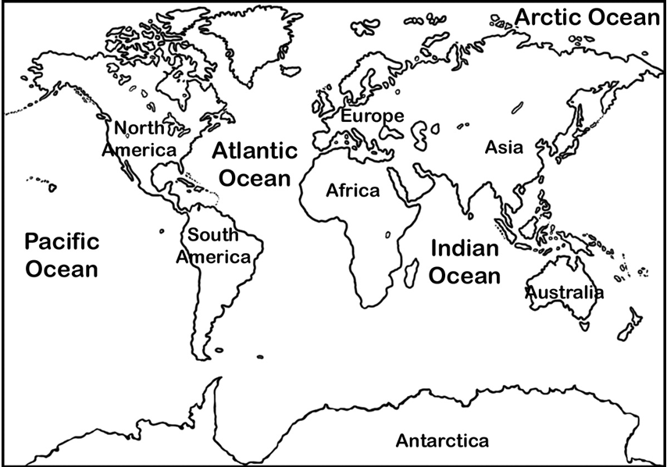

- Where is the majority of the sheet ice in the world located?

- What are the three effects of the melting of the sheet ice at the poles?

- Why is the other 1% of the sheet ice so important to human populations?

Global Warming, Heat, and the Water Cycle

- What two effects do increased surface temperatures have on the water cycle?

- According to the map, what region will experience:

December-February:

  - The greatest decrease in precipitation: ________________

  - The greatest increase in precipitation: ________________

June-August:

  - The greatest decrease in precipitation: ________________

  - The greatest increase in precipitation: ________________

Scientific Consensus

- In the 2004 survey of peer-reviewed papers, how many agreed with the IPCC’s conclusions?

- In the 2009 survey of Earth scientists, how many agreed with the IPCC’s conclusions?

Global Warming: Solutions

- Give two examples of prevention strategies:

- Give two examples of cleanup strategies:

- In the long run, what would be less expensive: prevention, or cleanup?

- How would the stratoshield help reduce global warming?

  - Would this cause acid rain or affect air quality?

  - Why might this seem like such a positive solution by most people?

- What is the cap-and-trade system, and how would it affect greenhouse gas emissions?

Action vs. Inaction

- Fill out the table below:

 | Significant Action | No Action
Global Climate Change is a fraud or is naturally occurring

Global Climate Change is real and primarily human-caused

- How does the image shown summarize the dilemma faced by humanity in dealing with global warming?

