Inconvenient Truth
Discussion Questions

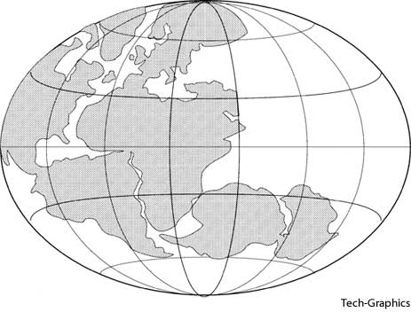
Background
- A quote often attributed to Mark Twain states,

“What gets us into trouble is not what we don't know. It's what we know for sure that just ain't so."

How does this relate to Pangaea and the Theory of Plate Tectonics?

- The sun emits three main wavelengths of energy that reach the earth. Which is responsible for global warming?

  - Infrared
  - Ultraviolet
  - Visible
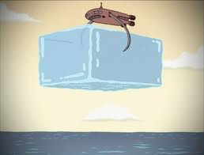
- A clip from the Futurama episode Crimes of the Hot is shown. At the end of the clip, global warming is “solved” by dropping larger and larger ice cubes into the ocean.

  - How is this a metaphor for how global warming has been handled in the real world?

  - Assume that humanity had the technology to mine and transport large amounts of ice from other planets to the Earth. Why would this solution not actually work?

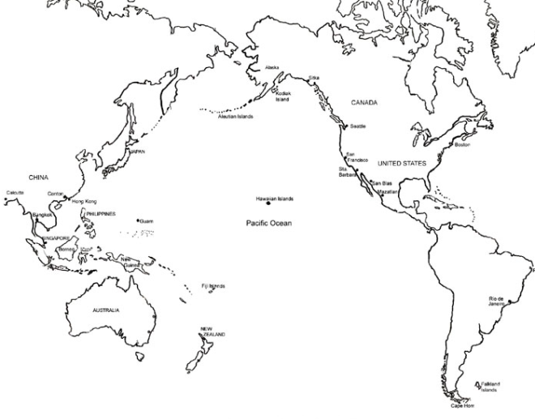

- A scientist named Charles David Keeling began recording daily carbon dioxide levels at an observatory in Mauna Loa, Hawaii in 1958. Why was this location chosen? How would data recorded at an observatory located near a city or forest be affected?

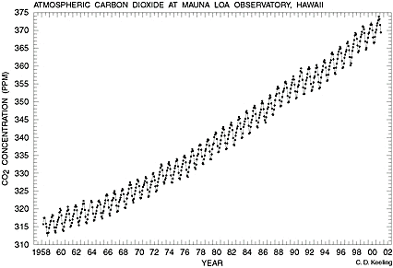
- The carbon dioxide graph to the right is often called the “Keeling Curve”. Why do the atmospheric CO₂ levels fluctuate up and down every year?

- Al Gore shows multiple pictures of glaciers that have melted significantly over the last few decades. Special attention was given to the glaciers of the Himalaya Mountains, due to the possibility they would disappear within the next 25 years. This statement, also found in the United Nations global warming report, was later retracted because it was based on the speculation of a single scientist, not actual data.
In your view, does this affect the documentary’s credibility?

- Ice cores are drilled and removed from the glaciers of Antarctica. The ratio of oxygen (Oxygen-16 and Oxygen-18) isotopes is measured and used to determine the approximate temperature during the time that part of the ice core was formed. This method is one example of a proxy. Explain what a proxy is, and why it is necessary research like this.

- Al Gore claims that the effects of the Clean Air Act of 1970 are visible in the Antarctic ice cores. This is actually inaccurate, as the effects are only visible from ice cores taken from the Arctic. Regardless, does this claim relate in any way to carbon dioxide pollution? Explain.

- This is the graph of carbon dioxide concentration and surface temperature as recorded from ice core data.

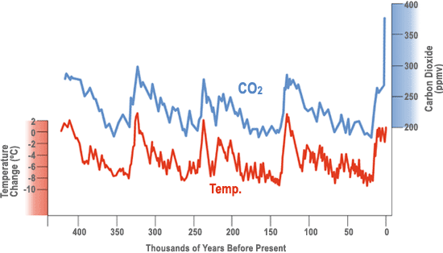

Is the relationship between CO2 and temperature a direct one? What would be a reasonable conclusion to draw from this graph?

- As a conclusion to this segment, Al Gore makes the following statement:

“This is really not a political issue so much as a moral issue. If we allow that to happen, it is deeply unethical.”

Do you believe this is a moral issue? Is the continued increase in carbon dioxide pollution by the human civilization deeply unethical? Explain your reasoning.

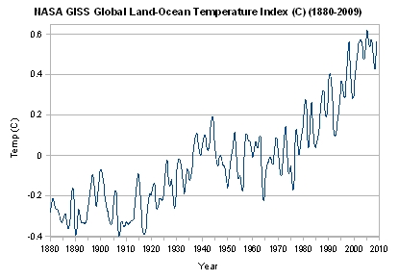
Ocean Temperatures and Hurricanes

- The graph above shows the change in ocean temperatures since the late 19th century. How does the warming of ocean water relate to the frequency of strong storms, such as hurricanes?

- Hurricane Katrina is used as an example of a storm linked the changes in ocean temperatures. When it originally struck Florida, it was a category 1 (74-95mph). Explain how this hurricane changed before it hit New Orleans and how this relates to global warming.

- This section is concluded with a quote given by Winston Churchill in late 1936:

“The era of procrastination, of half-measures, of soothing and baffling expedients, of delays, is coming to a close. In its place we are entering a period of consequences..."

Why does Gore choose this quote? What parallel is he attempting to draw between the circumstances of Churchill’s speech and the current global warming debate?

Effects on the Poles
- Due to the increase in global temperature, the duration and thickness of the permafrost of the northern tundra has been decreasing. Describe how each of these have been affected.
  - Alaska Oil Pipeline –
  - Truck Transportation –
  - Buildings –
  - Submarines surfacing –
- Why does snow and ice reflect much of the sun’s infrared energy, while ocean water absorbs it?

- The latitude of the United Kingdom is similar to that of Northern Quebec and Labrador in Canada, yet the temperatures are much milder. Use the diagram below to explain why.
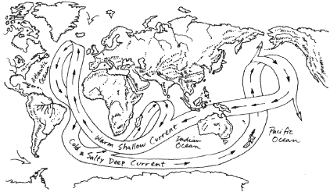

- How might the melting of Greenland’s glaciers impact this system?

Effects on Life
- What is the relationship between global warming and the increase of invasive species such as the Pine Bark Beetle?

- Al Gore states that species loss is currently occurring at a rate 1000x the normal background rate. There are multiple causes of extinction, with habitat loss generally considered the most significant. How does global warming contribute to habitat loss?

- Why was the collapse of the Larsen B ice shelf in Antarctica such a surprise to scientists?

- If the ice covering Greenland were to melt, how much would global sea levels rise?

- Explain why a rise in sea level is a concern for the human populations. Give specific cities that would be most at risk.

Technology
- Al Gore presents two formulas regarding technology:
“Old habits plus old technology = predictable consequences.”
“Old habits plus new technology = dramatically altered consequences.”
How does the given example of traditional vs. modern warfare compare with global warming and greenhouse gases? Why are the consequences of human actions so much greater now than in our past?

- The map below shows the relative contribution of each of the major countries/continents to global warming. Why is the United States the greatest contributor, even though we have a lower population than China or the entirety of Europe?
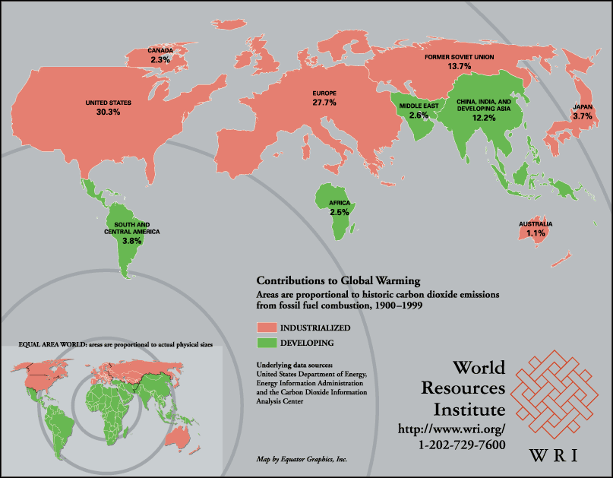

Call to Action
- A sample of 928 scientific articles regarding global climate change were surveyed to see how many disagreed with the IPCC’s conclusions that global warming is occurring and that it is primarily human caused. How many disagreed with these conclusions?

- What percent of the mass media articles disagreed with those conclusions?

- How does this quote from Upton Sinclair relate to the global warming “debate” as presented by the mass media?
"It's difficult to get a man to understand something if his salary depends on him not understanding it."

- Why is there such a big difference between the results of the two surveys?

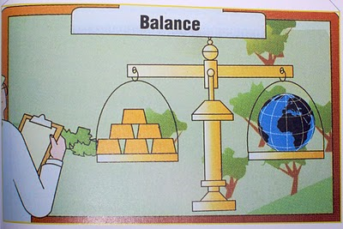
- The conflict between the economy and the environment is summarized in this image from a White House conference. Explain, in your own words, the decision we as a civilization are faced with.

- List three potential strategies that could be used to reduce carbon dioxide in the atmosphere.

Further Reading
- One potential solution of global warming that has been discussed is the stratoshield. Learn more about this idea at the Intellectual Ventures Lab website. Do you think this is a viable strategy, or a dangerous risk? Explain. Do you see any parallels between this and the satirical “Ice cube in the ocean” solution presented by the Futurama clip?
Article: http://intellectualventureslab.com/?p=474
Video: http://intellectualventureslab.com/?p=296

- The National Oceanic and Atmospheric Administration (NOAA) website (http://www.ncdc.noaa.gov/oa/reports/weather-events.html) has a list of current climate extreme events. Choose a specific, recent event from the list. Explain how this event may relate to planetary changes due to global warming.

- The Tragedy of the Commons is an essay written by Garrett Hardin about the abuse of natural resources that are not owned but shared by everyone. The two cartoons below summarize the essay.
http://www.garretthardinsociety.org/info/cartoon_commons1.html

http://www.garretthardinsociety.org/info/cartoon_commons2.html

Would you consider global warming and carbon dioxide pollution to be an example of a Tragedy of the Commons? Explain your answer.

