Introduction to Environmental Science

- What is environmental science?

- The environment includes:

- Environmental science is interdisciplinary because….

- Using the example of coal-for-electricity, describe how each of these fields of study is involved.

  - Economics –

  - Geology –

  - Engineering –

  - Chemistry –

  - Meteorology –

  - Ecology –

  - Politics -

Three Major Environmental Problems

- Define renewable resource –

  - Give one example of a renewable resource.

- Define nonrenewable resource –

  - Give one example of a nonrenewable resource.

  - What is the estimated remaining supply of coal?

- Define biodegradable pollution –

- Define nondegradable pollution –

- Mark the areas with the greatest concentrations of air pollution.

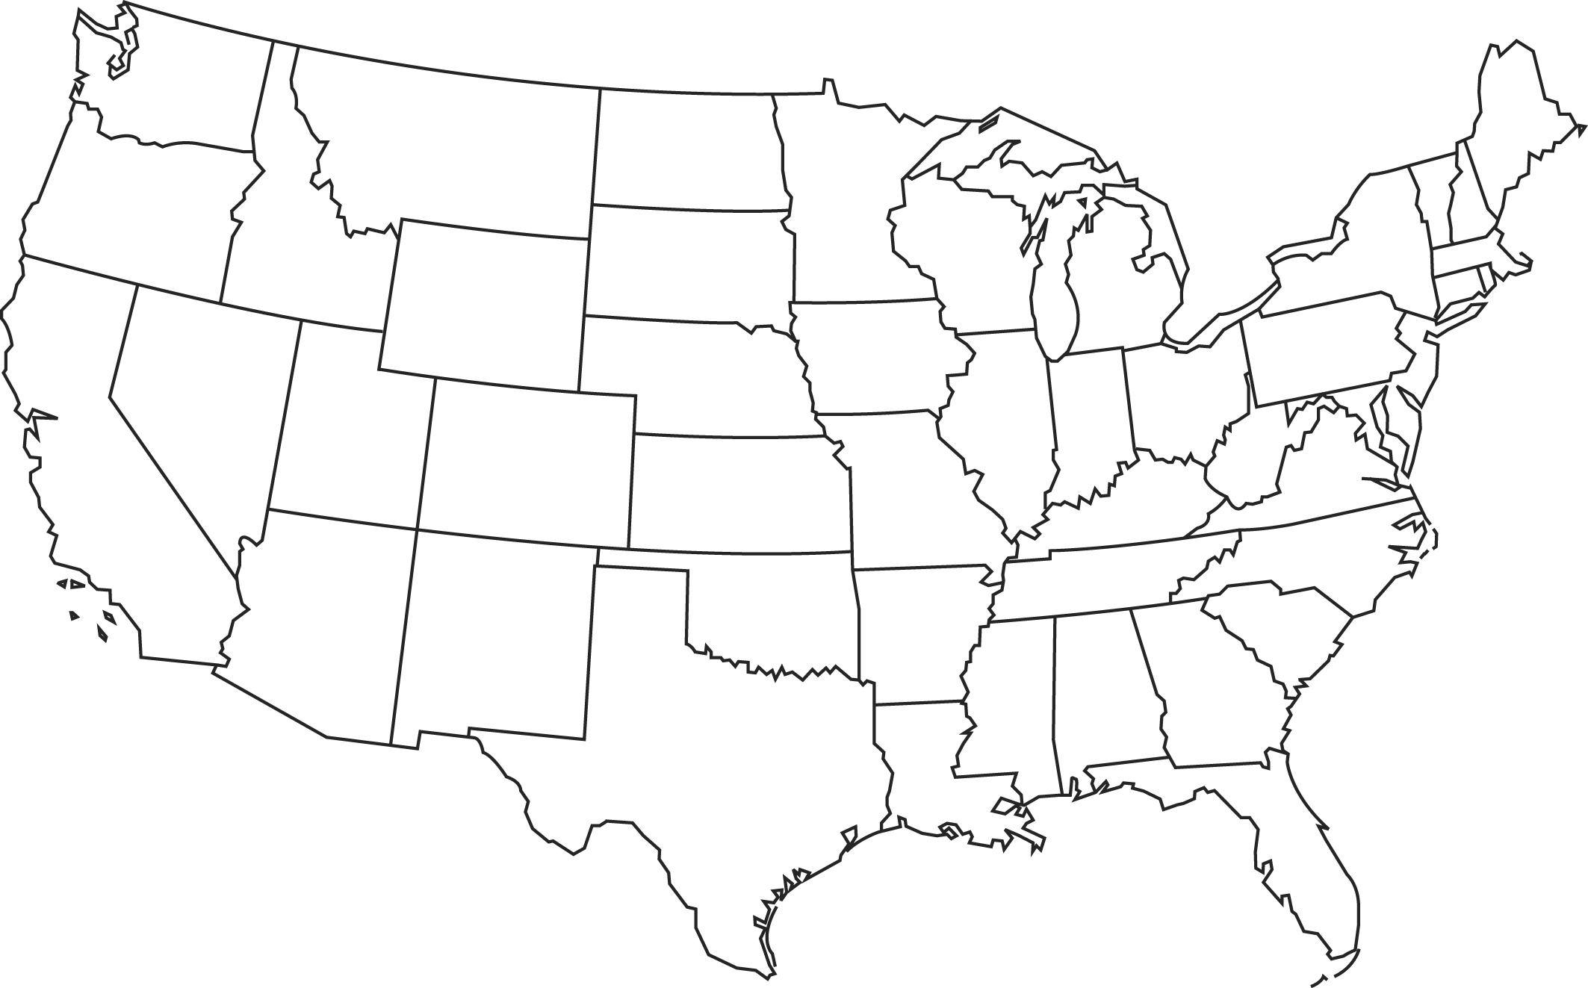

- Define biodiversity –

- Define extinction –

- How many known major extinction events have occurred in the history of Earth?

  - What caused the most recent one?

- What is the background rate for mammal extinctions?

  - How many mammal extinctions have occurred in Australia since 1788? What is the cause of these extinctions?

Environmental Ethics

- What is environmental ethics?

- What does anthropocentrism mean? Describe the philosophy.

- What does ecocentrism mean? Describe the philosophy.

- The proposed Hetch Hetchy dam was the first big debate between anthropocentrists and ecocentrists. Explain what each group wanted to do.

Anthropocentrists-

Ecocentrists -

- Was the dam constructed? Describe the reasoning. What environmental ethics philosophy aligns with this reasoning?

- What was the focus of the resource conservationism philosophy?

  - What two federal systems were created during this time?

- Two events lead to the beginning of the modern environmentalism movement. What were they?

  - What is the primary concern of modern environmentalists?

- What is global environmentalism?

The Tragedy of the Commons

- The Tragedy of the Commons essay describes the source of environmental problems as…

- What is a commons?

  - What tends to happen to commons areas?

  - What are modern examples of commons areas?

Economics and the Environment

- Define supply-and-demand –

  - Give an example.

- Define cost/benefit analysis –

  - Give an example.

- Describe the conditions found in a developing country.

- Describe the conditions found in a developed country.

- Which type of country has the smaller population size? Which consumes more resources?

- Compare and contrast developing and developed countries:

 |  | Developed  United States | Developing  Indonesia
Life expectancy
Population Growth Rate
Wealth
Energy Use
Pollution Rate
Waste Creation

- What factors are considered when calculating an ecological footprint?

- What is sustainability?

- Sustainability is important because the Earth is a closed system. What does this mean?

