Environmental Science Journal
Environmental Ethics and the Hetch Hetchy Decision

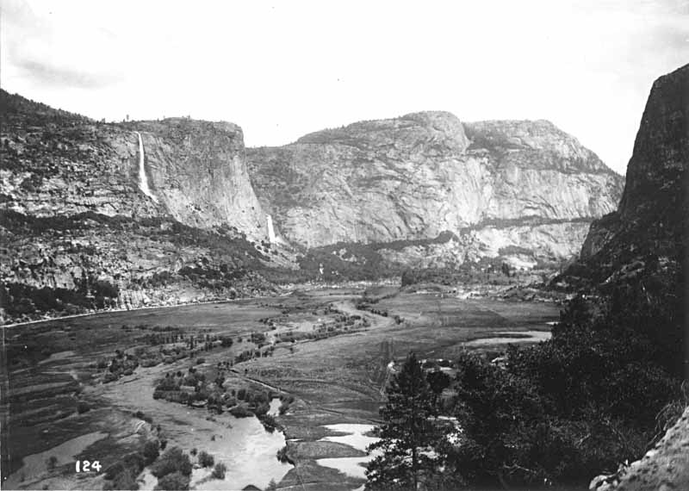

San Francisco is facing a severe water shortage in the early 20th century. The only nearby sources of water are the Pacific Ocean and the nearby smaller rivers. The salt water of the ocean cannot be filtered using available technology, and the local supply cannot adequately meet the needs of the growing population for much longer.

A larger river to the east could be dammed, but the dam would have to be built inside Yosemite National Park, which was originally set aside as a nature preserve. As president, you are ultimately responsible for making the decision whether or not to allow this dam to be built.

- Give the potential consequences of building and of not building the dam.

- Gifford Pinchot, the first chief of the Forest Service, said that our public lands should provide for "the greatest good for the greatest number". Explain what side an anthropocentrist would take in this debate.

- John Muir, the first president of the Sierra Club, condemned plants to build the dam, saying, "Dam Hetch Hetchy! As well dam for water-tanks the people's cathedrals and churches, for no holier temple has ever been consecrated by the heart of man." What ecocentric reasons might he have had to justify this stance?

- What decision would you ultimately make, and why? Explain whether you feel more closely aligned with the anthropocentrist philosophy of Gifford Pinochet, or the ecocentrist philosophy of John Muir?

