Environmental Science Study Guide
Municipal and Hazardous Waste Management

Vocabulary
Understand and be able to apply each of these terms.

- Waste Stream –
- Municipal Solid Waste -
- Hazardous Waste –
- Recycling –
- Composting –
- Tipping Fee –
- Leachate -
Critical Thinking
Be able to read, analyze, and give complete answers to questions like these.

- Give an example of biodegradable and non-degradable waste. Which can be composted?

- What are open dumps, and why are they now illegal in most developed countries?

- The two most common methods of municipal waste disposal are sanitary landfills and incinerators. What are the benefits and drawbacks of using each?

- Incinerators may either be mass burn or refuse-derived fuel. Describe how each works. Which is more environmentally damaging?

- Give two examples of benefits of recycling instead of sending material to a landfill.

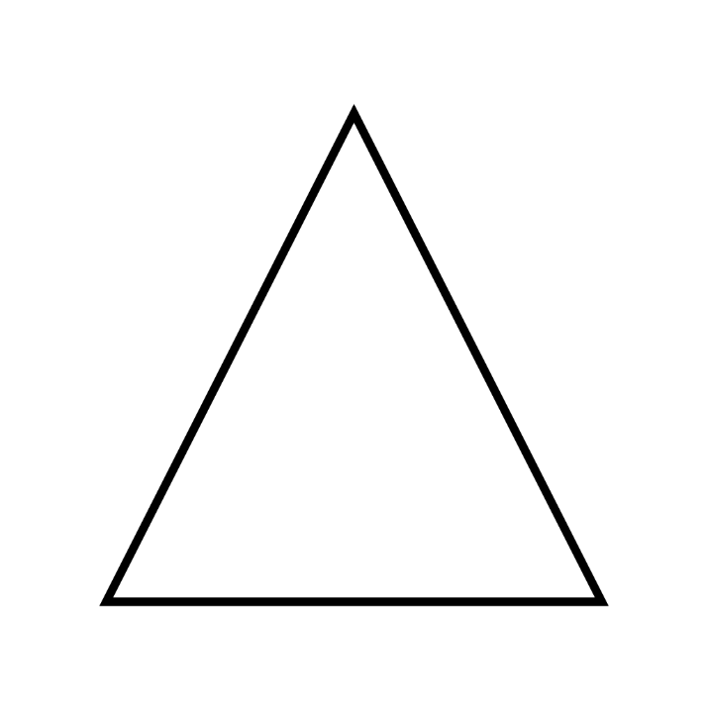
- Many communities now follow the integrated waste
management strategy of dealing with waste. Fill out the
triangle to the right with each of the five components of this
strategy.

  - Which of the strategies is the “first resort” and
preferred method of dealing with waste?

  - Which of the strategies is the “last resort”?
Why?

- Summarize what occurred during the Love Canal disaster and the legislation that was written in response to it.

- Give one example of household waste that might be considered hazardous waste. What specific property of this waste would cause it to be considered hazardous?

- Summarize what occurred during the Khian Sea waste disposal incident. What international agreement was drafted to stop further incidents like this?

  - What form of waste is still heavily exported in spite of this agreement?

- Give an example of high-level and low-level nuclear waste.

- If an element of high-level waste has a half-life of 3 days, how long would it take before less than 5% of the material remained?

